Ashcon Abae

Signals and Systems

October 22, 2019

Exam #1

1. We know: $$δ\left[n-k\right]x\left[n\right]=x[k] \\ y\left[n\right]=\sum_{k=-∞}^{∞}{x\left[k\right]g[n-2k]} \\ g\left[n\right]=u\left[n\right]-u[n-4]$$ 
   1. For $x\left[n\right]=δ[n-1]$: $$y\left[n\right]=\sum_{k=-∞}^{∞}{δ[k-1]g[n-2k]}$$ 
      Since k only exists at 1, $y\left[n\right]=g\left[n-2\right]=u\left[n-2\right]-u[n-6]$
   2. For $x\left[n\right]=δ[n-2]$: $$y\left[n\right]=\sum_{k=-∞}^{∞}{δ[k-2]g[n-2k]}=g\left[n-4\right]=u\left[n-4\right]-u[n-8]$$
   3. Let’s suppose that for $x\left[n\right]=δ[n]$: $$y\left[n\right]=\sum_{k=-∞}^{∞}{δ\left[k\right]g[n-2k]}=g[n]$$ 
      For this system to be time invariant, it would mean that: $x[n]↔g[n]$ 
      , then $x[n-1]↔g[n-1]$. But since $x[n-1]↔g[n-2]$, the system must be time variant.
2. Here, $y\left[n\right]=z\left[n\right]-z[n-1]$, where $z\left[n\right]=2x\left[n\right]-y[n-1]$  
   Substituting, we get: $$y\left[n\right]=2x\left[n\right]-y\left[n-1\right]-2x\left[n-1\right]-2y[n-2]$$ 
   That is, $$y\left[n\right]+y\left[n-1\right]+2y\left[n-2\right]=2(x\left[n\right]-x\left[n-1\right])$$
3. To determine and sketch y[t]=x[t]\*h[t], let’s first sketch x[t] and h[t], respectively:  
   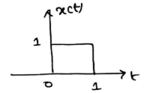 = x[t]  
   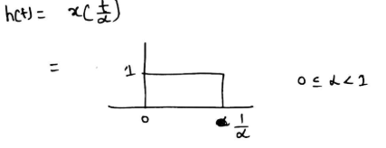 = h[t]  
   1. Now, we can sketch y[t]=x[t]\*h[t]:  
      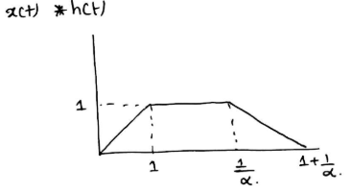 = y[t]
   2. From our sketch above, we can see that if $\frac{dy\left[t\right]}{dt}$ contains only 3 discontinuities, then $α=1$ because our sketch would look like below:  
      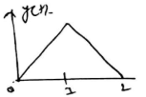 = y[t], where $2=1+\frac{1}{α}$
4. x[-1] = -1, x[0] = 0, x[1] = 1  
   v[0] = 1, v[1] = 1, v[2] = 1  
   This can be rewritten as: $$x\left[n\right]=δ\left[n-1\right]-δ\left[n+1\right] \\ v\left[n\right]=δ\left[n\right]+δ\left[n-1\right]+δ\left[n-2\right]$$ 
   So we can write the convolution y[n] = x[n]\*v[n]: $$y\left[n\right]=x\left[n\right]*v\left[n\right]=\sum_{k=-∞}^{∞}{x\left[k\right]v\left[n-k\right]}$$ 
   Substituting the values we receive from the original discrete time signals, we can solve for the convolution sum: $$y\left[n\right]=δ\left[n\right]*δ\left[n-1\right]-δ\left[n+1\right]*δ\left[n\right]+δ\left[n-1\right]*δ\left[n-1\right]-δ\left[n+1\right]*δ\left[n-1\right]+δ\left[n-1\right]*δ\left[n+2\right]-δ\left[n+1\right]*δ\left[n+2\right] \\ y\left[n\right]=δ\left[n-1\right]-δ\left[n+1\right]+δ\left[n-2\right]-δ\left[n\right]+δ\left[n+1\right]-δ\left[n-3\right] \\ y\left[n\right]=-δ\left[n-3\right]-δ\left[n\right]+δ\left[n-1\right]+δ[n-2]$$ 
   Finally, we can plot the result below:  
   